Steps Required to Update Organisation Id across the FCS Solution

Re-Run XrmMigrator
The XrmMigration tool has been upgraded to migrate organisations that have an Organisation id of “0” as well as no value. This will sweep up the migrations that were missing when Release 2a went live.
The latest source files will need to be downloaded and build with the correct solution configuration (Release).
The command to run the console application is:
XrmMigrator.exe -migration org
Expected Output:
The Console Window should show a verbose output of all organisations being migrated, and should not be zero. At the time of writing the estimate for number of organisations is 1004, this may increase as contracts are loaded into production. Below is an example console window for 20 orgs migrated:
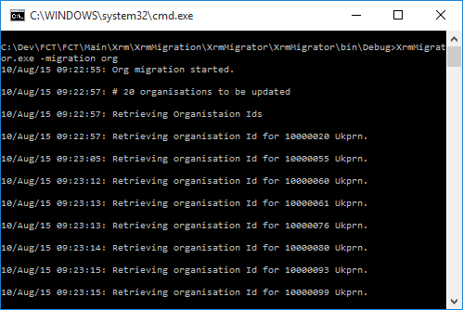
The log file should also include the detail included in the console window. Attached below is an example log for 20 org migrations

Extract the Updated Organisation Ids from Dynamics CRM.

After the update to organisations has been completed in Dynamics CRM, this data will need to be extracted to update other data stores within the FCS Solution.
A SQL Script has been added to the XrmMigrator Solution under Solution Items folder.
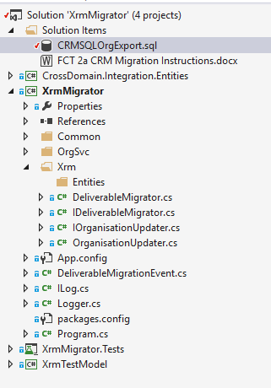

CRMSQLOrgExport.sql

This script needs to be run on the CRM Organization Database (e.g. SkillsFundingAgency_MSCRM) by a SQL administrator.
Expected Output:
A number of rows that contain update statements for the Payment Generation and Payment Schedule services:
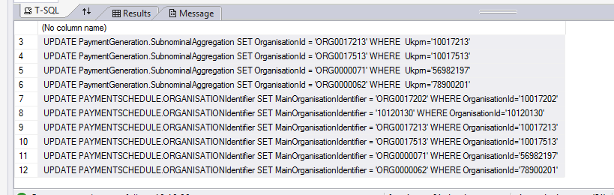
This script will then need to be executed against the Production SQL Database (i.e. fct-database-release)
This will then update all the organisation ids in the local data stores.
Verify--
Table: PaymentSchedule.OrganisationIdentifer
Column: MainOrganisationIdentifier
AND
Table: PaymentGeneration.SubnominalAggregation
Column: OrganisationId
--do not have any NULL or zero values.

Re-seed the Contract Management Service ATOM feed

In order to ensure these updated organisation Ids appear in the ATOM feed, the following actions will need to be taken:
- Determine how many Approved Contracts are present in CRM:
  - Open CRM in a browser. URL and credentials as follows:
    - OAT:
      - Url: https://fcs-pp-crmw.preprod.fcs.sfa.bis.gov.uk/skillsfundingagency
      - Username: fcspreprod\CRMIntegration
      - Password: Pa55w0rd!
    - Production:
      - Url: https://fcs-prd-crmw.prod.fcs.sfa.bis.gov.uk/skillsfundingagency
      - Username: fcsprod\CRMIntegration
      - Password: Pa55w0rd!
  - Click on “Advanced Find”
  - Select the dropdown options in the below screenshot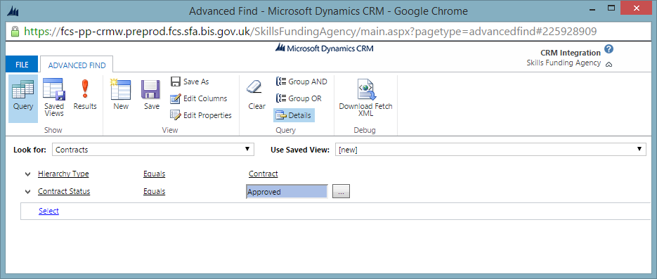
  - Click the “Results” icon
  - The number of approved contracts will be displayed in the bottom left as per screenshot below 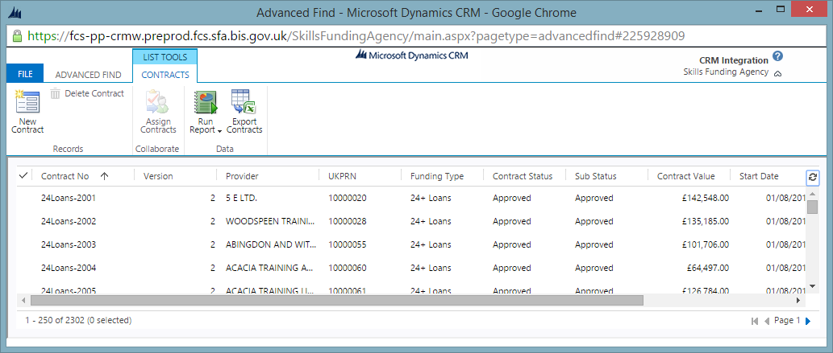

- Connect to the Production Azure Table Store for Production
- Determine how many records are in the ApprovedContract table prior to deleting it. This should be the same as the number in CRM, however it is possible it will be less.
- Delete the following tables:
  - ApprovedContract
  - ApprovedContract_Correlation
- Wait approximately 2 minutes for Azure to process the delete request
- Open solution $FCT\Main\CrossDomain.Integration\CrossDomain.Integration.sln
- Build solution in Release configuration
- Amend the following settings in config file $FCT\Main\CrossDomain.Integration\AtomSeed\bin\Release\AtomSeed.exe.config
  - ​CrmConnectionString - should be set to correct CRM connection string
  - ​StorageConnectionString - should be set to correct Azure storage connection string
  - StorageTableSuffix - environment-specific Azure table name suffix. For production this should be empty, i.e. <add key="StorageTableSuffix" value="" />. For environments where the Azure storage account is shared this should be set to the correct enviornmental suffix, e.g. OAT, CI
- Run console app with following command:
  - $FCT\Main\CrossDomain.Integration\AtomSeed\bin\Release\AtomSeed.exe approvedcontract
This will seed the Atom feeds.
- Verify that the number of records in the ApprovedContracts table is the same as the number of ApprovedContracts in CRM.
- To verify that the updated Organisation Ids appear in the feed, the AtomFeedTestClient can be used (located in TFS -> FCT\tools\AtomFeedTestClient). There are configuration transforms for both OAT and Release environments. Provide the ‘-all’ argument to the console application to retrieve data for all feeds.
- To verify that the UOP Codes appear in the Atom feed it will be necessary to find an OLASS contract in the AtomTestClient output. Do this by searching for the text “uopCode” and verifying the presence of the field in the XML for an OLASS contract.

